(Muhammad Abdullah)
FA24-BSE-042
INSTRUCTOR :SIR MUZAFFAR

lab assignment 6
Programming fundamentals

LAB ACTIVITIES

Activity:01
  - This activity demonstrate usage of Math class functions. Following program prompts the user to enter the x- and y-coordinates of the three corner points in a triangle and then displays the three angles.
Code:
import java.util.Scanner;
public class Lab06 {
public static void main(String[] args) {
Scanner input = new Scanner(System.in);
// Prompt the user to enter three points
System.out.println("Enter three points");
System.out.print("Enter x1: ");
double x1 = input.nextDouble();
System.out.print("Enter y1: ");
double y1 = input.nextDouble();
System.out.print("Enter x2: ");
double x2 = input.nextDouble();
System.out.print("Enter y2: ");
double y2 = input.nextDouble();
System.out.print("Enter x3: ");
double x3 = input.nextDouble();
System.out.print("Enter y3: ");
double y3 = input.nextDouble();
// Compute three sides
double a = Math.sqrt((x2 - x3) * (x2 - x3) + (y2 - y3) * (y2 - y3));
double b = Math.sqrt((x1 - x3) * (x1 - x3) + (y1 - y3) * (y1 - y3));
double c = Math.sqrt((x1 - x2) * (x1 - x2) + (y1 - y2) * (y1 - y2));
// Compute three angles
double A = Math.toDegrees(Math.acos((a * a - b * b - c * c) / (-2 * b * c)));
double B = Math.toDegrees(Math.acos((b * b - a * a - c * c) / (-2 * a * c)));
double C = Math.toDegrees(Math.acos((c * c - b * b - a * a) / (-2 * a * b)));
// Display results
System.out.println("The three angles are " + Math.round(A * 100) / 100.0 + "," + Math.round(B * 100) / 100.0 + "," + Math.round(C * 100) / 100.0);
}
}

Output:

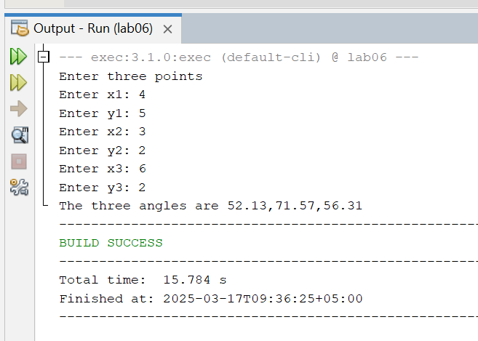
Activity:02
  - This activity illustrate useful methods of Character class.
Code:
public class Lab06 {
public static void main(String[] args) {
System.out.println("isDigit('a') is " + Character.isDigit('a'));
System.out.println("isLetter('a') is " + Character.isLetter('a'));
System.out.println("isLowerCase('a') is "+
Character.isLowerCase('a'));
System.out.println("isUpperCase('a') is "+
Character.isUpperCase('a'));
System.out.println("toLowerCase('T') is "+
Character.toLowerCase('T'));
System.out.println("toUpperCase('q') is "+
Character.toUpperCase('q'));
}
}
Output:

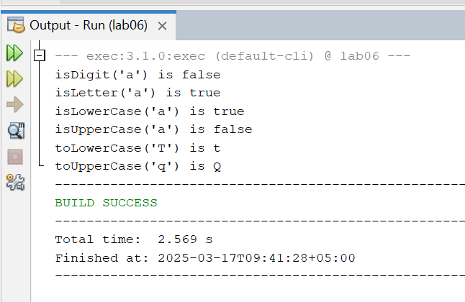
Activity:03
  - This acitivty uses compareTo() method to display two cities, entered by user, in alphabetical order.
Code:
import java.util.Scanner;
public class Lab06 {
public static void main(String[] args) {
Scanner input = new Scanner(System.in);
// Prompt the user to enter two cities
System.out.print("Enter the first city: ");
String city1 = input.nextLine();
System.out.print("Enter the second city: ");
String city2 = input.nextLine();
if (city1.compareTo(city2) < 0){
System.out.println("The cities in alphabetical order are " + city1 + " " + city2);
}
else {
System.out.println("The cities in alphabetical order are " +city2 + " " + city1);
}
}
}
Output:
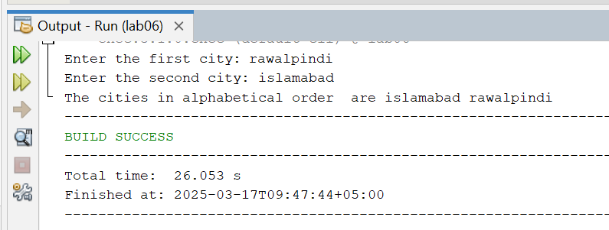
Activity:04
  - This program illustrate how various String methods work.
Code:
public class Lab06 {
public static void main(String[] args) {
String sentence;
String str1;
String str2;
int index;
sentence = "Now is the time for the birthday party";
System.out.println("sentence = \"" + sentence + "\"");
System.out.println("The length of sentence = "+ sentence.length());
System.out.println("The character at index 16 in "+ "sentence = " + sentence.charAt(16));
System.out.println("The index of first t in sentence = "+ sentence.indexOf('t'));
System.out.println("The index of for in sentence = "+ sentence.indexOf("for"));
System.out.println("sentence.substring(0, 6) = \""+ sentence.substring(0, 6) + "\"");
System.out.println("sentence.substring(7, 12) = \""+ sentence.substring(7, 12) + "\"");
System.out.println("sentence.substring(7, 22) = \""+ sentence.substring(7, 22) + "\"");
System.out.println("sentence.substring(4, 10) = \" "+ sentence.substring(4, 10) + "\"");
str1 = sentence.substring(0, 8);
System.out.println("str1 = \"" + str1 + "\"");
str2 = sentence.substring(2, 12);
System.out.println("str2 = \"" + str2 + "\"");
System.out.println("sentence in uppercase = \""+ sentence.toUpperCase() + "\"");
index = sentence.indexOf("birthday");
str1 = sentence.substring(index, index + 14);
System.out.println("str1 = \"" + str1 + "\"");
System.out.println("sentence.replace('t', 'T' ) = \""+ sentence.replace('t', 'T') + "\"");
}
}

Output:

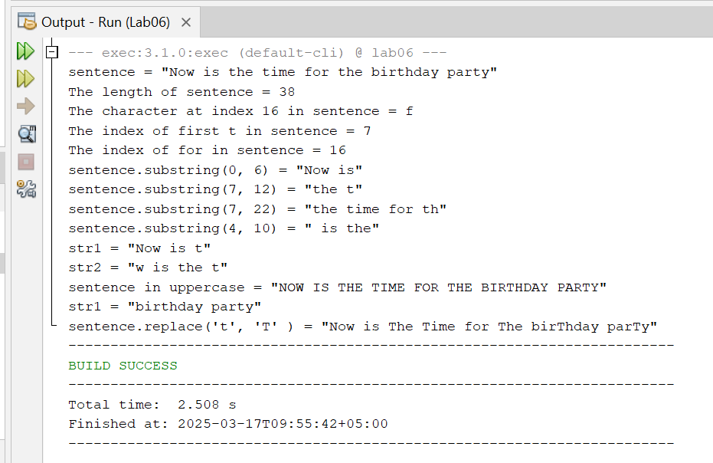

LAB TASKS
Lab Task:01
  - 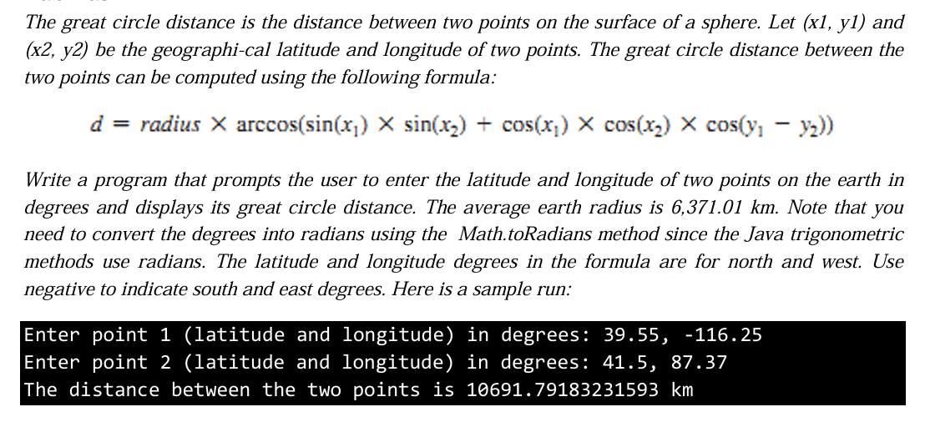
Code:
import java.util.Scanner;
public class Lab06 {
public static void main(String[] args) {
Scanner input=new Scanner(System.in);
System.out.print("Enter the latitude of point1: ");
double x1=input.nextDouble();
x1= Math.toRadians(x1);
System.out.print("Enter the longitude of point1: ");
double x2=input.nextDouble();
x2= Math.toRadians(x2);
System.out.print("Enter the latitude of point2: ");
double y1=input.nextDouble();
y1= Math.toRadians(y1);
System.out.print("Enter the longitude of point2: ");
double y2=input.nextDouble();
y2= Math.toRadians(y2);
double radius= 6371.01;
double distance = radius * Math.acos(Math.sin(x1) * Math.sin(x2) + Math.cos(x1) * Math.cos(x2) * Math.cos(y1 - y2));
System.out.print("The estimated distance between points is "+distance);
}}
Output:

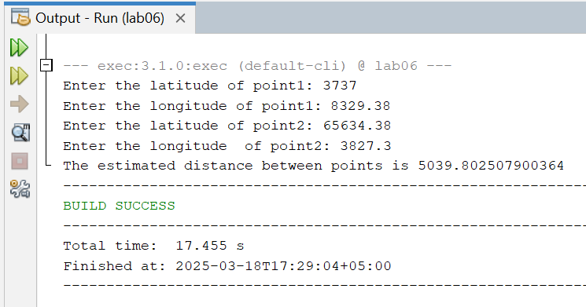

Lab Task:02
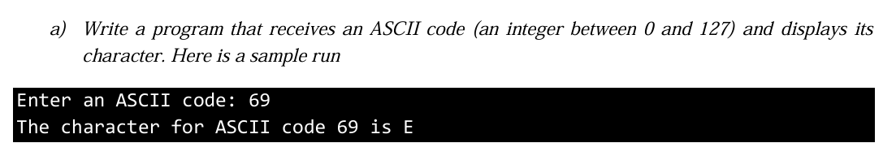
PART(A)

Code:
public class Lab06 {
public static void main(String[] args) {
int x = (int) (Math.random() * 128);
char character = (char) x;
System.out.println("The character for ASCII code " + x + " is: " + character);
}
}

PART(B)
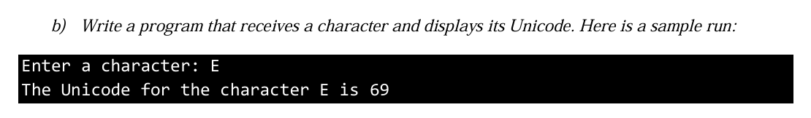
import java.util.Scanner;
public class Lab06 {
public static void main(String[] args) {
Scanner input = new Scanner(System.in);
System.out.print("enter the character: ");
char character = input.next().charAt(0);
int unicode = (int) character;
System.out.println("The Unicode code for the character" + character + " is: " + unicode);
}
}

Output:

PART(A)

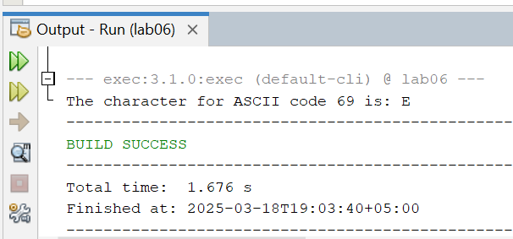

PART(B)

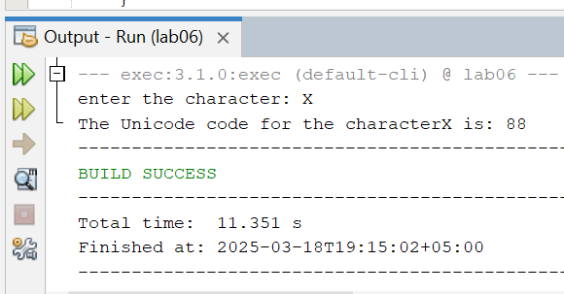

Lab Task:03

Code:
PART(A)
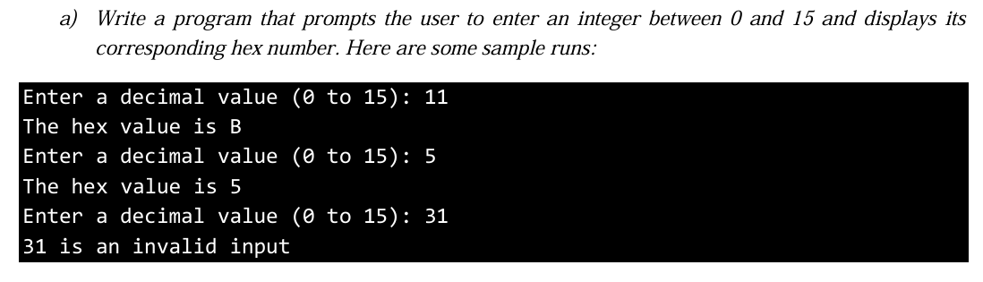
import java.util.Scanner;
public class Lab06 {
public static void main(String[] args) {
Scanner input = new Scanner(System.in);
System.out.print("Enter an integer (0-15): ");
int num = input.nextInt();
if (num >= 0 && num <= 15) {
String hex = Integer.toHexString(num).toUpperCase();
System.out.println("The hexadecimal equivalent of " + num + " is: " + hex);
} else {
System.out.println("Invalid input! Please enter a number between 0 and 15.");
}
}
}

PART(B)
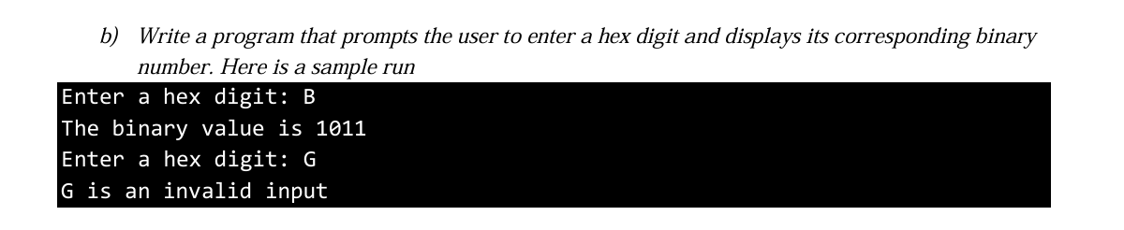

import java.util.Scanner;
public class Lab06 {
public static void main(String[] args) {
Scanner input = new Scanner(System.in);
System.out.print("Enter a hexadecimal digit (0-9, A-F): ");
String number = input.next().toUpperCase();
if (number.length() == 1 && number.matches("[0-9A-F]")) {
int decimal = Integer.parseInt(number, 16); // Convert hexadecimal to decimal
String binary = Integer.toBinaryString(decimal); // Convert decimal to binary
System.out.println("The binary equivalent of " + number + " is: " + binary);
} else {
System.out.println("Invalid input! Please enter a single hex digit (0-9, A-F).");
}

}
}

Output:

PART(A)

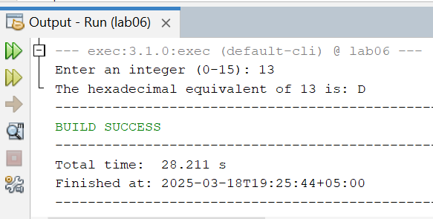

PART(B)

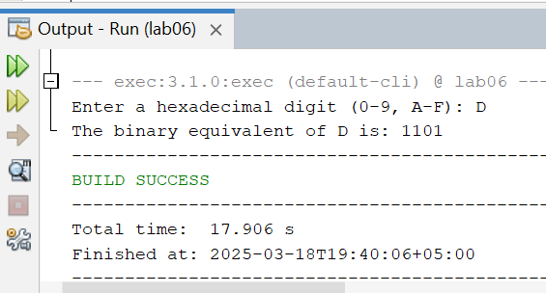

Lab Task:04
  - Write a program that displays a random uppercase letter using the Math.random() method.
Code:
public class Lab06 {
public static void main(String[] args) {
char randomLetter = (char) ((int) (Math.random() * 26) + 65);
System.out.println("Random Uppercase Letter: " + randomLetter);
}
}
Output:
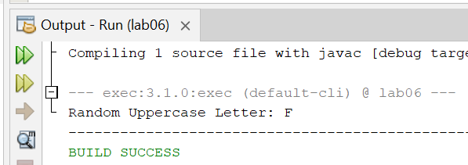

Lab Task:05
  - Write a program that checks whether a string is a palindrome. A string is a palindrome if it reads the same forward and backward. The words “mom,” “dad,” and “noon,” for instance, are all palindromes. Sample run: Enter a string: noon noon is a palindrome Enter a string: moon moon is not a palindrome
Code:
import java.util.Scanner;
public class Lab06 {
public static void main(String[] args) {
Scanner input = new Scanner(System.in);
System.out.print("Enter a string: ");
String str = input.nextLine();
String reversedStr = "";
for (int i = str.length() - 1; i >= 0; i--) {
reversedStr += str.charAt(i);
}
if (str.equals(reversedStr)) {
System.out.println(str + " is a palindrome");
} else {
System.out.println(str + " is not a palindrome");
}
}
}
Output:
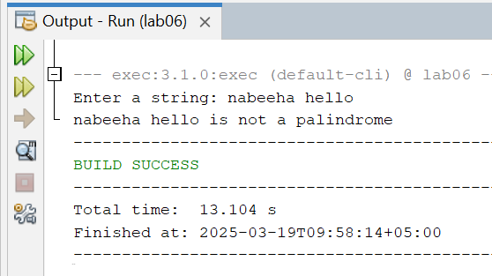

Lab Task:06
  - Given a string consisting of exactly two words separated by a space. Print a new string with the first and second word positions swapped (the second word is printed first). This task should not use loops and if.
Code:
import java.util.Scanner;
public class Lab06 {
public static void main(String[] args) {
Scanner input = new Scanner(System.in);
System.out.print("Enter a string: ");
String str = input.nextLine();
String[] words = str.split(" ", 2);
System.out.println(words[1] + " " + words[0]);
}
}

Output:
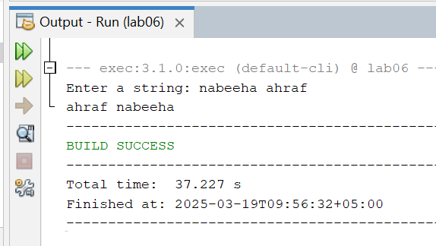

Lab Task:07
  - Given a string that may or may not contain a letter of interest. Print the index location of the first and last appearance of f. If the letter f occurs only once, then output its index. If the letter f does not occur, then do not print anything.
Code:
import java.util.Scanner;
public class Lab06 {
public static void main(String[] args) {
Scanner input = new Scanner(System.in);
System.out.print("Enter a string: ");
String str = input.nextLine();
int firstIndex = str.indexOf('f');
int lastIndex = str.lastIndexOf('f');
if (firstIndex != -1) {
if (firstIndex == lastIndex) {
System.out.println(firstIndex);
} else {
System.out.println(firstIndex + " " + lastIndex);
}
}
}
}

Output:
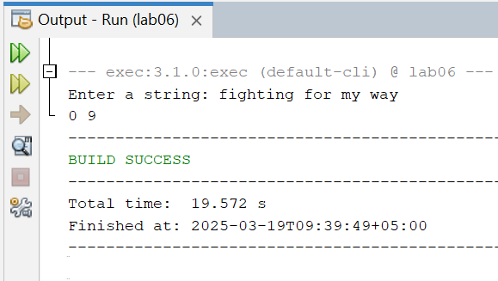

Lab Task:08
  - Given a string in which the letter h occurs at least twice. Remove from that string the first and the last occurrence of the letter h, as well as all the characters between them.
Code:
import java.util.Scanner;
public class Lab06 {
public static void main(String[] args) {
Scanner input = new Scanner(System.in);
System.out.print("Enter a string: ");
String str = input.nextLine();
int firstIndex = str.indexOf('h');
int lastIndex = str.lastIndexOf('h');
String result = str.substring(0, firstIndex) + str.substring(lastIndex + 1);
System.out.println(result);
}
}

Output:
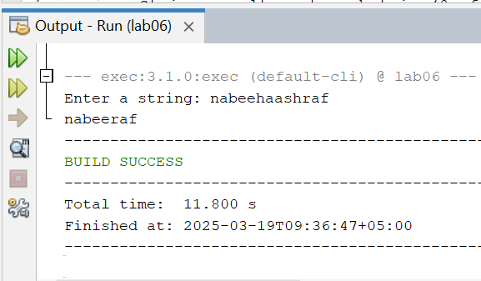

Lab Task:09
  - Given a string. Replace every occurrence of the letter h by the letter H, except for the first and the last ones
Code:
import java.util.Scanner;
public class Lab06 {
public static void main(String[] args) {
Scanner input = new Scanner(System.in);
System.out.print("Enter a string: ");
String str = input.nextLine();
int firstIndex = str.indexOf('h');
int lastIndex = str.lastIndexOf('h');
StringBuilder modifiedStr = new StringBuilder(str);
for (int i = 0; i < str.length(); i++) {
char x = str.charAt(i);
if (i == firstIndex || i == lastIndex) {
continue;
}
if (x == 'h') {
modifiedStr.setCharAt(i, 'H');
}
}
System.out.println(modifiedStr.toString());
}
}

Output:
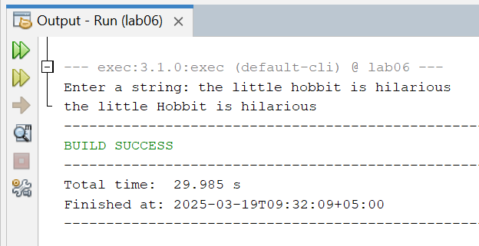

Lab Task:10
  - You are given a string. In the first line, print the third character of this string. In the second line, print the second to last character of this string. In the third line, print the first five characters of this string. In the fourth line, print all but the last two characters of this string. In the fifth line, print all the characters of this string with even indices (remember indexing starts at 0, so the characters are displayed starting with the first). In the sixth line, print all the characters of this string with odd indices (i.e. starting with the second character in the string). In the seventh line, print all the characters of the string in reverse order. In the eighth line, print every second character of the string in reverse order, starting from the last one. In the ninth line, print the length of the given string.
Code:
import java.util.Scanner;
public class Lab06 {
public static void main(String[] args) {
Scanner input = new Scanner(System.in);
System.out.print("Enter a string: ");
String str=input.next();
// 1.Third character of the string
System.out.println(str.charAt(2));
// 2.Second to last character
System.out.println(str.charAt(str.length() - 2));
// 3.First five characters
System.out.println(str.substring(0, 5));
// 4.All but the last two characters
System.out.println(str.substring(0, str.length() - 2));
// 5.Characters at even indexes
for (int i = 0; i < str.length(); i += 2) {
System.out.print(str.charAt(i));
}
System.out.println();
// 6.Characters at odd indexes
for (int i = 1; i < str.length(); i += 2) {
System.out.print(str.charAt(i));
}
System.out.println();
// 7.Reverse string
for (int i = str.length() - 1; i >= 0; i--) {
System.out.print(str.charAt(i));
}
System.out.println();
// 8.Every second character in reverse order
for (int i = str.length() - 1; i >= 0; i -= 2) {
System.out.print(str.charAt(i));
}
System.out.println();
// 9.Length of the string
System.out.println(str.length());
}
}

Output:
